There are two types of power-assisted pedal cycles approved for use in Tasmania that do not require registration for use on a public space and these are:
- Power-assisted pedal cycle with an engine or motor/s that provides up to 200 watts output
- A Pedalec.
This information bulletin aims to provide some clarification into the legal use of power-assisted pedal cycles.
At all times the regulatory requirements take precedence over the information provided here.

Power-assisted pedal cycle – maximum power output 200 watts
A power-assisted pedal cycle is a type of powered cycle which may be a bicycle or tricycle which is equipped with pedals used by a person for propulsion and has one or more auxiliary motors to assist the rider.
The primary source for propulsion on these cycles must be via the use of the pedals by the rider.
The auxiliary motor/s on a power-assisted pedal cycle must not be capable of producing a combined maximum power output exceeding 200 watts, whether or not the motor/s are operating. The power from the motor/s may be controlled by a throttle or accelerator.

Pedalec
A Pedalec is a bicycle fitted with an electric motor that meets the European Standards for power-assisted pedal cycles. The standards applicable are EN15194/ . Please note, these standards are amended from time to time.
To comply with EN5194 the Pedalec cycle must adhere to the following conditions
- the a maximum continuous power output of the motor cannot exceed 250watts
- the motor must cut-off once the cycle reaches 25km/h or sooner if the rider stops pedalling
- the cycle must be certified by the manufacturer and labelled as complying with EN15194
- the label must identify the manufacturer’s name, the motors cut-off speed in km/h and the continuous rated power of the motor in watts
The rider must pedal the cycle to activate the motor. Pedalecs may be equipped with an optional low-speed start-up mode that allows the motor to power the cycle to 6km/h. This mode is activated by the user either when riding without pedalling or when the user is pushing the cycle.

Road Rules for the use of power-assisted pedal cycles and Pedalecs
Riders of power-assisted pedal and Pedalec cycles do not require a drivers licence or motor vehicle registration.
The rider must wear an approved bicycle helmet and is required to obey the same rules for other bicycles.
The bicycle must be fitted with effective brakes and a:
- Bell or other audible warning device
- Rear facing red reflector
- White light directed to the front at night
- Red light directed to the rear at night.

Cycles that are not considered power-assisted pedal cycles
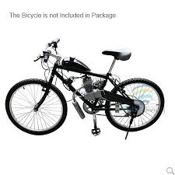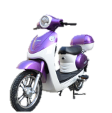
Bicycles fitted with an internal combustion engine/s that have a power output or combined output greater than 200 watts, such as a lawn mower, chainsaw or brush cutter engine are not considered as a power-assisted pedal cycle and cannot be used on a public space.
Note: The information provided by most of the manufacturers of these lawn mower, chainsaw or brush cutter engines indicates that they far exceed the 200 watt limit.
For the purpose of the Vehicle and Traffic Act 1999 these devices are a motor vehicle and require registration and drivers licences for use. The riders need to obtain a specific drivers licence. These vehicles are required to obey all regulations as a motor bike and other registered motor vehicles.
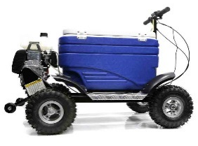
Other powered recreational devices
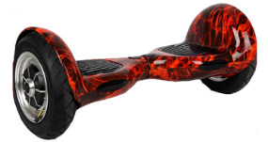

Motorised Scooter means a scooter that is propelled by one or more electric motors and complies with the following
- Its maker certifies (either by means of a plate attached to the motor/s, or by means of engraving on the motor/s) the ungoverned power output of the motor/s;
- The maximum power output of the motor, or the combined maximum power output of the motors, is not more than 200 watts;
- When propelled only by the motor/s, the scooter is not capable of going faster than 10 km/h on level ground;
The Road Rules stipulates where motorised scooters are permitted to be used.
A motorised scooter that is equipped with an engine or motor/s other than electric are not permitted to be used on a public place.
Other devices (such as motorised Eski’s) used for transporting a person or persons that is equipped with an engine or motor/s are not permitted to be used on a public place.
For the purpose of the Vehicle and Traffic Act 1999 these devices are a motor vehicle and require registration and drivers licences for use. As these devices cannot meet the regulatory requirements for motor vehicles, they are unsuitable for registration and cannot be used in a public space.

Note: It is not possible to convert cubic centimetres (CC), cubic inches (CI) or litres to watts.
In order to determine if an engine meets the 200 watts requirement it is required to know the rated brake horse power (BHP) of the engine in question. BHP can then be converted to watts by multiplying the BHP by 0.7460. For example 1.8bhp x 0.7460 = 1.3kw = 1300watts.
Web Links;

Vehicle and Traffic Act 1999
http://www.thelaw.tas.gov.au/tocview/index.w3p;cond=;doc_id=70%2B%2B1999%2BAT%40EN%2B20140219140000;histon=;prompt=;rec=;term
Tasmanian Road Rules
http://www.thelaw.tas.gov.au/tocview/index.w3p;cond=all;doc_id=%2B142%2B2009%2BAT%40EN%2B20151106000000;histon=;prompt=;rec=;term
The European Standards for Pedalecs can be purchased form; http://infostore.saiglobal.com/store/details.aspx?ProductID=1105032
For more information contact:
Department of State Growth
Vehicle Registration and Standards
GPO Box 536
Hobart TAS 7001
Phone: (03) 03 6166 3263
Fax: (03) 03 6233 3837
Email: vehicle.standards@stategrowth.tas.gov.au
Web: www.transport.tas.gov.au

