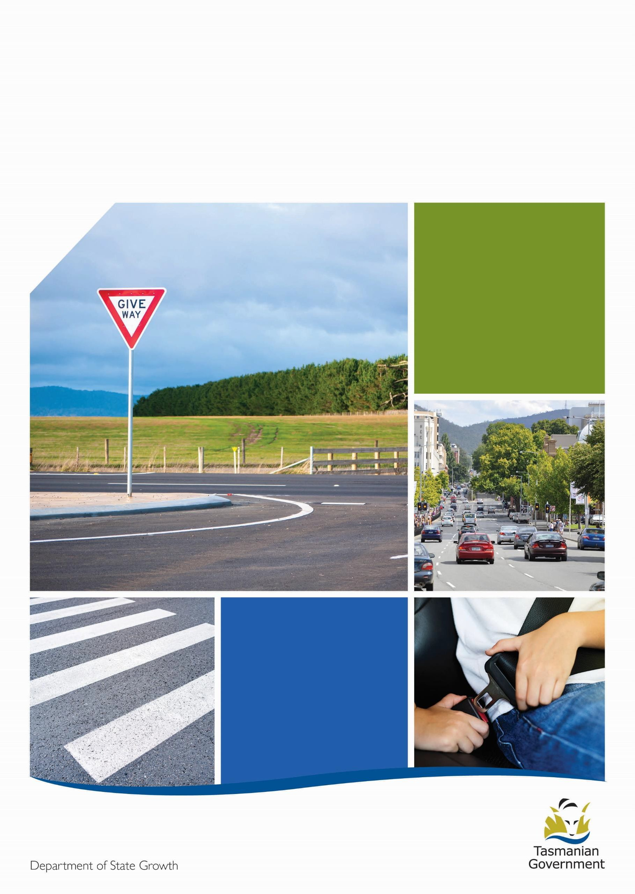
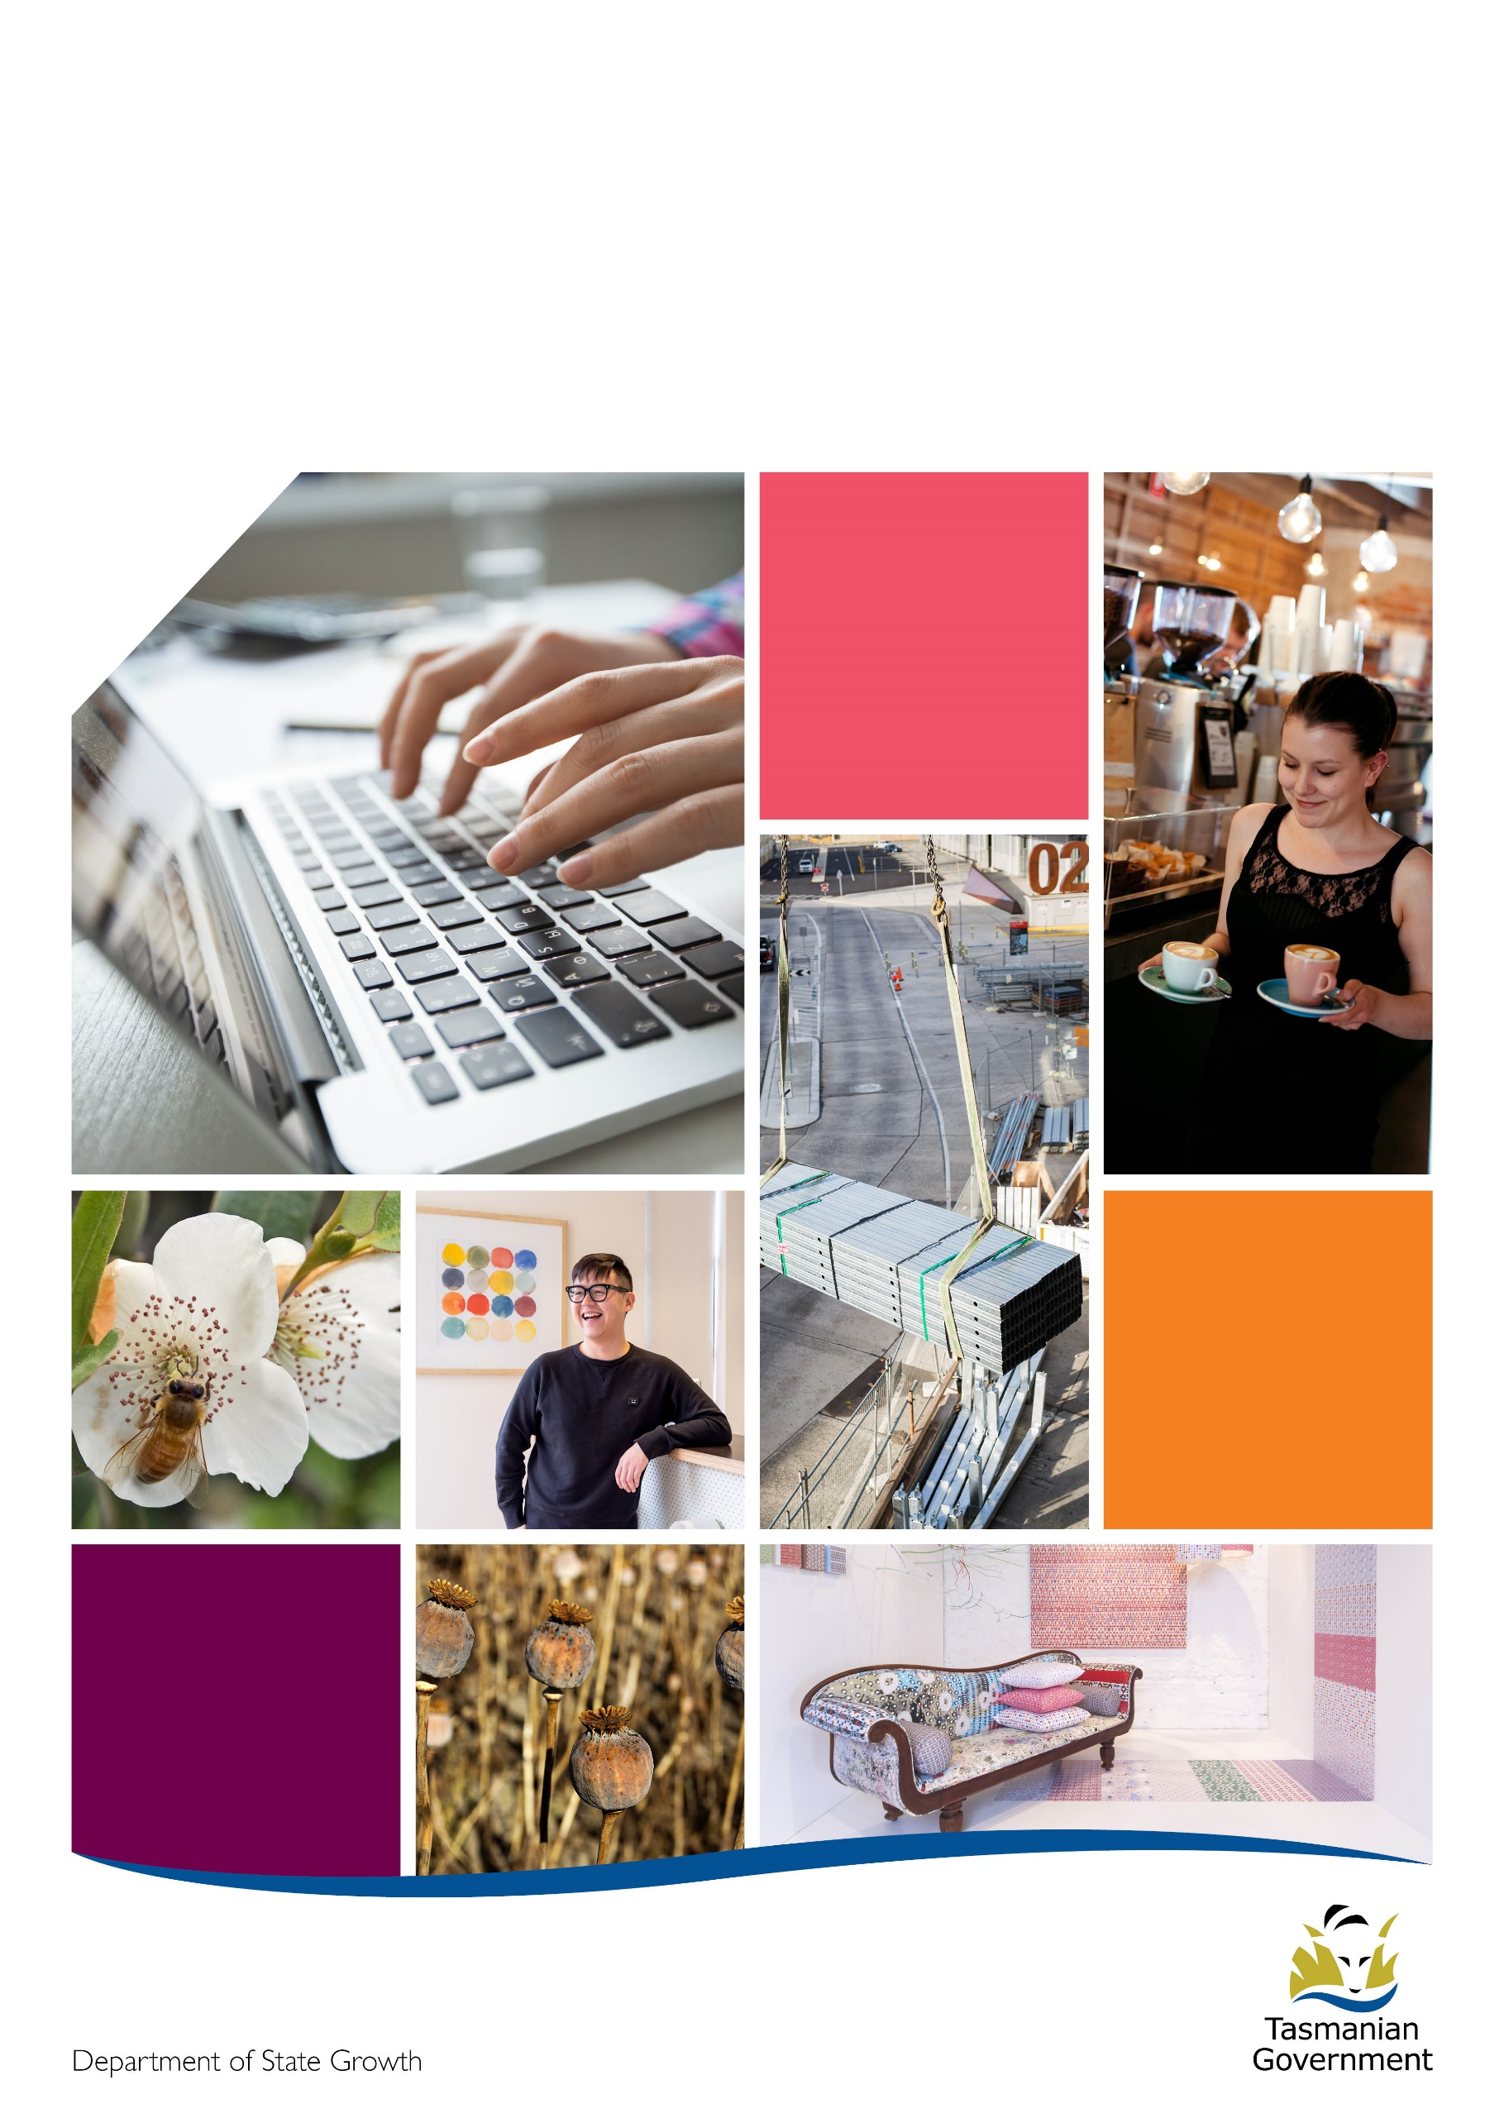

2023-24 Program Guidelines

Community Road Safety Grants

Contents
Contents i
Road safety in Tasmania 1
Our vision 1
The Safe System approach 1
Community Road Safety Grants (CRSG) 2023-24 1
Fatal Five road safety behaviours 1
Road user groups 2
CRSG Funding 2
Category One – Small Grants 2
Category Two – Medium/Large Grants 2
Funding exclusions 2
1. Eligibility criteria 2
Example projects 3
Ineligible applicants 3
Digital Message Boards 3
Projects that will not be funded 3
2. Assessment criteria 3
3. Timeframes 4
4. Application process 4
5. Successful applicants 5
Funding agreements 5
Reporting requirements 5
Acknowledging the RSAC 5
Road Safety Advisory Council logo 5
6. Appealing a decision 5
7. Grant payments 5
8. Taxation and financial implications 6
9. Acquittal 6
How to acquit a grant 6
Failure to complete an acquittal 6
10. Administration and contact details 6
Note 6
11. Publicity of grant assistance 6
12. Right to information 7
13. Confidentiality 7
14. Personal information protection 7
15. Disclosure 7
16. Disclaimer 7

Version number | Updated on | Updated by | Approved by
V1 | 06 September 2023 | Alysse Gavlik, Senior Consultant | Craig Hoey, Manager Road Safety

Road safety in Tasmania

Our vision
Currently around 300 people are seriously injured and killed on Tasmanian roads each year. Our long-term goal for road safety in Tasmania is to have a ‘Safe System’ of zero serious injuries and deaths on our roads.
The Towards Zero – Tasmanian Road Safety Strategy 2017–2026 (Towards Zero Strategy) works towards this goal by setting a target for the annual number of serious injuries and deaths on Tasmanian roads to fewer than 200 by 2026.

The Safe System approach
The Towards Zero Strategy is based on the Safe System approach, which is internationally recognised for improving road safety. The Safe System approach is underpinned by the belief that all road-related serious injuries and deaths are preventable and therefore no loss of life is acceptable.
The human body is fragile and not designed to tolerate the impact experienced in motor vehicle crashes, particularly higher speed crashes. A Safe System aims to strengthen the whole system with each of the four elements working together to reduce harm from road crashes:
- Safe Road Users – encouraging safe behaviour through education, enforcement and regulation
- Safe Roads and Roadsides – designing and maintaining roads to reduce the risk and severity of crashes
- Safe Vehicles – designing vehicles that protect occupants, reduce the likelihood of a crash and simplify the driving task
- Safe Speeds – establishing speed limits that are more appropriate to the safety features of individual roads.
All four Safe System elements must work together and continue to be improved to prevent serious injury and death on our roads. All elements should be strong enough either individually or collaboratively to reduce the effects of a crash that results from a specific weakness of one element.
Safe System thinking requires us all to accept responsibility for road safety, including road and traffic engineers, vehicle designers, manufacturers and marketers, police, educations, trauma managers, local government and community groups, as well as each of us as individual road users.
Community road safety is a key feature of the Towards Zero Strategy. It is recognised that the Tasmanian community’s active engagement in road safety continues to be one of the major contributors to reduce our road trauma. Communities can support our vision of zero serious injuries and fatalities by developing initiatives that incorporate the Safe System approach to road safety.

Community Road Safety Grants (CRSG) 2023-24
The Community Road Safety Grants (CRSG) program aims to provide community groups across Tasmania with the opportunity to develop and deliver small scale, local programs within their communities consistent with the Towards Zero Strategy.
The Government has committed $200,000 from the Road Safety Levy each financial year under the Towards Zero Action Plan 2020–2024 (the Action Plan) to the CRSG, supported by the Road Safety Advisory Council (RSAC). The CRSG is administered as a competitive grant round every financial year by the Department of State Growth.
RSAC makes recommendations to the Tasmanian Government about road safety policy and public education programs, expenditure of the Road Safety Levy and oversees advertising campaigns. Their work is based on the Towards Zero Strategy.
Projects must address at least one of the Fatal Five road safety behaviours or road safety user groups in the categories below and demonstrate a community focus by addressing a local issue which is evidence-based and has community support. Proposed projects also need to meet the project assessment criteria outlined in this document.

Fatal Five road safety behaviours
- Speeding
- Distraction
- Driving under the influence of alcohol or drugs
- Fatigue
- Failure to wear seatbelts

Road user groups
- Young drivers
- Children, especially 0–5 years and 12–15 years
- Pedestrians
- Bicycle riders
- Motorcyclists
- Older road users

CRSG Funding
CRSG funding is available in two categories: small grants and medium/large grants. Other more substantial grants may be considered by special application, and must include a cash contribution from either the applicant’s own funds or from another funder of at least 20 per cent of the amount being requested from the CRSG program.
Detailed project plans are required to demonstrate the community need, road safety benefit and proposed project expenditure.
Funding can cover the cost to develop and implement a project, including staff costs, but does not include general administration costs such as for internet, telephone, office space and travel.
Applications for this grant will be competitively assessed. Because the program has limited funding, potentially not all eligible applicants will be successful.
The Funding Assessment Panel has the discretion to fund a project partially or in full.

Category One – Small Grants
Grants up to $5,000 (plus GST) are available for local community road safety projects. Projects in this category aim to increase road safety awareness in specific community groups or locations.

Category Two – Medium/Large Grants
A limited number of $35,000 (plus GST) road safety grants are also available. This category applies to more significant projects that involve a broader reach within the community.

Funding exclusions
CRSG funding excludes the following:
- organisations with overdue CRSG reporting obligations
- projects undertaken predominantly outside of Tasmania
- projects that produce a private benefit to a specific business or person(s)
- retrospective funding, ie for costs already incurred before a grant deed is signed
- ongoing operational costs
- items or services the applicant is contracted to provide
- insufficiently defined items, eg contingency, sundry and miscellaneous items
- strategic, business or communication plans or feasibility studies or any other study that does not result in a direct outcome.

Eligibility criteria
For any queries about the eligibility criteria, contact the community road safety team by emailing roadsafetygrants@stategrowth.tas.gov.au or phoning 1800 030 688.
Applicants may be asked to supply documentation to support their eligibility claims, as part of the application process, or as part of an audit process.
To be eligible for the grant applicants must:
- be able to demonstrate they are financially viable and have public liability insurance on request
- have acquitted any previous grants received through the CRSG program
- be registered for tax purposes in Australia with an active Australian Business Number (ABN) and valid bank account.
Eligible applicants include:
- local government
- not-for-profits
- incorporated associations
- schools
- other service areas within the Department of Education (DoE)
- Tasmanian research institutions.

Example projects
Projects should raise awareness and foster safer road user behaviours, outcomes or promotions, including responsible community behaviours and cultures:
- Promotional activities, eg signage, advertising, stickers, poster competitions, banners or roadside speed display placement
- Educational activities and resources, eg brochures, short films, social media projects, competitions, quizzes, displays, child restraints or safe driving or safe vehicle workshops
- Initiatives, research or policies, eg safer driver policies and handbooks, local community road safety research, strategies and plans, community events or bicycle safety programs
- Events or event initiatives, eg free vehicle health checks, child restraint checks or workplace / community / school road safety days.

Ineligible applicants
- Businesses
- Other Tasmanian Government agencies (except schools)
- Individuals

Digital Message Boards
The RSAC does not fund the purchase of Digital Message Boards (DMB), this includes speed trailer displays. However, funding will be available for hire and transportation of DMBs that are incorporated into a larger scale project.

Projects that will not be funded
Project | Description
Projects that duplicate existing or proposed RSAC projects | The CRSG program aims to support local projects with road safety benefits that do not already have resources allocated by the RSAC.
Learner Driver Mentor Programs (LDMPs) | Funding is already available through LDMP grants. For more information, visit the Transport Services LDMP webpage (1)
Driver training, including defensive driving | Learner driver support is available through the LDMP and further driver training usually requires specialist knowledge to deliver evidence-based training
Infrastructure projects | Other funding sources are available for these types of road safety projects, such as the Vulnerable Road User Program. For more information, visit the Transport Services VRUP webpage (2)
(1) https://www.transport.tas.gov.au/road_safety_and_rules/grants_programs/learner_driver_mentor_program
(2) https://www.transport.tas.gov.au/road_safety_and_rules/grants_programs/vulnerable_road_user_program

Assessment criteria
Each application for CRSG funding will be competitively assessed based on the quality of information provided by the applicant. Applicants must ensure all information is included when submitting their application. Please note, potentially not all eligible grant applicants will receive funding.
Assessment Criteria | Description
- Towards Zero Strategy and /or Safe System approach alignment | How the project will work towards road safety improvements to support the Towards Zero Strategy and Action Plan using Safe Systems principles
- Addresses a road safety behaviour or group - based on evidence | Why a road safety issue affecting the community needs to be addressed, and evidence to support the grant application
- Target group identified | How the project will meet the needs of the target group and addressing clear road safety outcomes
- Stakeholder and community support | Who will contribute to the project, and who in the community has an interest in the project’s success. Include evidence of consultation or supporting documentation.
- Budget aligns with proposed project | Whether the projects costs are reasonable and justified

Timeframes
No applications will be accepted after the closing date.
Description | Date
Program opens | 27 October 2023
Program closes | 24 November 2023
Applications assessed | 28 November 2023
Applicants notified | 11 December 2023
All applicants will receive a notification on the outcome of their application in writing.

Application and Assessment processes
The Department of State Growth uses an online grants management system called SmartyGrants. This system is easy to use and accessible via mobile phones, tablets, laptops and personal computers.
- Applicants should read the guidelines carefully before starting an application. The application form is designed to help structure applicants’ responses to the eligibility and assessment criteria.
- This is a competitive, merit-based process. Meeting the eligibility criteria will not automatically result in a successful grant.
- Applicants should complete and lodge an application online via SmartyGrants from the CRSG program website https://www.transport.tas.gov.au/road_safety_and_rules/grants_programs/community_road_safety_grants_program.
- Applicants who are unable to apply online via SmartyGrants can access a manual application by emailing roadsafetygrants@stategrowth.tas.gov.au.
- Applicants should, ensure that all supporting documentation provided is accurate and is attached correctly before submitting. Additional information will only be allowed when requested by the department.
- During the assessment process the department may, at its discretion, require further information to support or clarify an application. This information must be provided within three working days, unless otherwise advised. Failure to provide further requested information within the timeframe may result in the application being unsuccessful.
- Following the submission of the application via SmartyGrants, applicants will receive an automatic receipt of their application. This receipt will include details of the application and a unique application ID. If this notification is not received within 30 minutes of lodgement, please contact roadsafetygrants@stategrowth.tas.gov.au to confirm whether the grant was lodged successfully.
- Applicant and project eligibility will be assessed by a departmental assessment team and forwarded to an independent Funding Assessment Panel for final evaluation.
- The Funding Assessment Panel will provide recommendations to the General Manager, Road User Services for approval.

Successful applicants

Funding agreements
Successful applicants will be required to enter a formal agreement that outlines the funding terms and conditions in the form of either a grant deed, or a letter between the Department and the applicant. The grant deed or letter must be signed by both the applicant and the Department of State Growth. The department has the discretion to cancel the grant if this is not done within the advised timeframes.
Funds must be used as indicated in the funding application and in accordance with the CRSG terms and conditions and your funding approval document.

Reporting requirements
The RSAC wants to hear how the project achieved its objectives and outcomes.
Grant recipients must provide a final report within two months of project completion as a funding condition. The project completion date, and other key dates as required, will be determined by the dates listed in the initial funding application. Any changes to the completion date need to be approved following written application to the Department.
Final project reports will document the project outcomes and achievements and measure its success in meeting the original objectives. Grant recipients are encouraged to include additional qualitative information in reports such as photographs, newsletters, newspaper clippings or good news stories.
Failure to provide a final report by the deadline may impact a recipient’s eligibility to apply for future grants. Where extensions are required, recipients must contact the Community Road Safety team in writing to negotiate a new reporting submission date.

Acknowledging the RSAC
Grant recipients are required to acknowledge the funding support provided, to promote the Road Safety Levy as a funding source for the CRSG. Particular conditions for this acknowledgement are included in the grant deed.
Common methods to recognise the CRSG program include acknowledgment in newsletters and annual reports, and through display of logos. Please note, when acknowledging RSAC support, the logo and/or the words ‘supported by the Road Safety Advisory Council’ should be used, as specified in the grant deed. Grant recipients should make application in writing to the Department for approval of all intended uses of the RSAC logo. Please allow two weeks for approval of use. Approval for marketing activities will not be unreasonably withheld.
As a condition of the grant deed, State Growth is to be advised of any event, function or launch to ensure appropriate representation and participation by members of RSAC, State Growth and/or the Minister for Infrastructure and Transport for opportunities to acknowledge the Towards Zero Strategy and Action Plan, and the CRSG funding provided.

Road Safety Advisory Council logo
The RSAC logo below must be used. It must not to be changed or distorted, eg changes to colours, font or proportions, and must be used appropriately in respect to other logos displayed. The grant recipient must contact State Growth before use as outlined above to ensure the logo is appropriately displayed.

Appealing a decision
The appeals process is designed to ensure that all applicants have been treated fairly and consistently in applying for Department of State Growth grants. The Department will consider appeals relating to administrative process issues in grants management.
All requests must be in writing and should be addressed to Martin Crane, General Manager, Road User Services at martin.crane@stategrowth.tas.gov.au or GPO Box 536, Hobart TAS 7001.
Your request must be received within 28 days from the date of the Department of State Growth notifying you of the decision about your application. For further information about the process, contact roadsafetygrants@stategrowth.tas.gov.au.

Grant payments
Successful applicants will be asked for their bank account details to process grant payments. This bank account must be in the same name as the, organisation that applied for the grant. Applicants may be asked to provide a copy of their bank statement or a letter from their bank to confirm their bank account details.
Providing incorrect bank account details may result in funds being paid to an incorrect account. These funds will need to be returned to us before we attempt another grant payment. This process may result in significant delays in funding being received. Additionally, we cannot guarantee that funds paid to an incorrect bank account will be returned to us.
If a grant recipient:
- does not complete the activities or tasks required under the funding agreement,
- does not use any or all of the funding provided, the recipient may be required to return some or all of the funds to the department.
Similarly, if
- the information provided to us is found to be false or misleading, or
- the recipient’s situation changes in a way that prevents completion of the agreed project
the recipient will be required to return some or all of the funds to the department.

Taxation and financial implications
Grants distributed under the program attract GST. Grant payments to successful applicants who are registered for GST are increased to compensate for the amount of GST payable. A valid tax invoice must be supplied by the successful applicant to the department, including GST. If an organisation is not registered for GST, the tax invoice must only state the grant fund amount.
The receipt of funding from this program may be treated as income by the Australian Taxation Office (ATO).
It is strongly recommended that, prior to submitting an application, potential applicants seek independent advice from a tax advisor, financial advisor and/or the ATO, about the possible tax implications for receiving the grant.

Acquittal
An acquittal is a statement made by a grant recipient, confirming that the grant funding was used as per the funding agreement. Unless otherwise stated, it is a requirement that all Department of State Growth grants are acquitted.

How to acquit a grant
An acquittal form will be provided to recipients, asking for information about the activities and expenditure relating to the grant. Evidence such as quotations, invoices, receipts, statements, reports, etc., are also required to support the acquittal.
The department may ask recipients to provide a Statement of Expenditure certified by an independent, professional auditor. In this situation the recipient will be responsible for the cost of obtaining the certified Statement of Expenditure.

Failure to complete an acquittal
Failure to lodge a valid acquittal by the due date may result in the recipient being required to return the funding to the department. In this situation the department will invoice the recipient.

Administration and contact details
The program will be administered by the Department of State Growth on behalf of the Crown in the Right of Tasmania. Contact the Community Road Safety team on roadsafetygrants@stategrowth.tas.gov.au or 1800 030 688.

Note
All applicants must take care to provide true and accurate information. Any information that is found to be false or misleading may result in action being taken and grant funds, if already provided, will be required to be repaid to the department.

Publicity of grant assistance
The Department of State Growth disburses public funds and is therefore accountable for the distribution of those funds. As part of the accountability process, the department may publicise the level of financial assistance, the identity of the recipient, the purpose of the financial assistance, and any other details considered by the department to be appropriate.

Right to information
Information provided to the Department of State Growth may be subject to disclosure in accordance with the Right to Information Act 2009.

Confidentiality
The Tasmanian Government may use and disclose the information provided by applicants for the purposes of discharging its respective functions under the Program Guidelines and otherwise for the purposes of the program and related uses.
The department may also:
- Use information received in applications for any other departmental business.
- Use information received in applications and during the delivery of the project for reporting purposes.

Personal information protection
Personal information will be managed in accordance with the Personal Information Protection Act 2004.
This information may be accessed by the individual to whom it related, on request to the Department of State Growth. A fee for this service may be charged.

Disclosure
The following applies to all successful applicants:
- Despite any confidentiality or intellectual property right subsisting in the grant funding agreement or deed, a party may publish all or any part of the grant funding agreement or deed without reference to another party.
- Please note that all obligations under the Personal Information Protection Act 2004 (Tas) and the Privacy Act 1988 (Cwlth) still apply.

Disclaimer
Although care has been taken in the preparation of this document, no warranty, express or implied, is given by the Crown in Right of Tasmania, as to the accuracy or completeness of the information it contains.
The Crown in Right of Tasmania accepts no responsibility for any loss or damage that may arise from anything contained in or omitted from or that may arise from the use of this document, and any person relying on this document and the information it contains does so at their own risk absolutely.
The Crown in Right of Tasmania does not accept liability or responsibility for any loss incurred by an applicant that are in any way related to the program.

Department of State Growth

4 Salamanca Place
Hobart TAS 7001 Australia

Phone: 1800 030 688
Email: roadsafetygrants@stategrowth.tas.gov.au
Web: www.stategrowth.tas.gov.au

