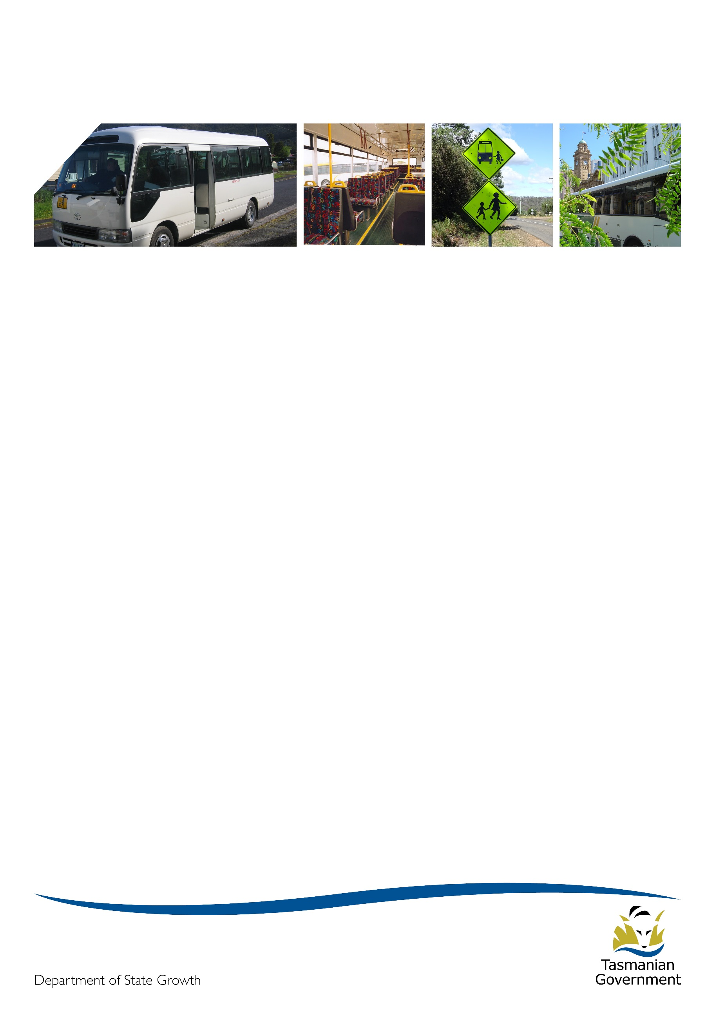
Transporter

October 2021

October newsletter contents
COVID-19 – short notice southern lock down 1
Life is back to normal in Orford 2
Huonville Express service 2
Printable maps and timetables now available for school bus services 3
General Access network changes launched 3 October 2021 3
Student free travel bus passes 2022 4
Student fare increase 2022 4
Contacting Passenger Transport 4

COVID-19 – short notice southern lock down
As we saw recently in southern Tasmania, Directions from the Department of Heath such as lockdowns or a requirement to wear face masks in public can come into effect at any time.
In a lockdown, public transport services (including school bus services) continue to operate as scheduled. This is important to:
- allow essential workers to get to their jobs
- provide access to essential services such as food shopping and medical appointments
- enable students who cannot be supervised at home to get to school
- spread passenger travel demand, thereby increasing the capacity for social distancing on board.
Passenger Transport would like to offer our deep thanks and appreciation to all our operators who helped keep the network running during this critical time. Your assistance in supporting passengers with masks, and protecting the community with additional cleaning, helps keep Tasmanians safe and moving.
In southern Tasmania, facemasks continue to be required by any person 12 years of age or older who is outside their home, unless they have a medical exemption, until 6pm Friday 22 October (subject to further guidance).
In advance of any potential lockdown or mask mandate situation, the Passenger Transport Branch issued face masks to operators of general access, school bus, and ferry services. This was to assist in the initial hours of a short notice Department of Heath Direction taking effect.
This supply was to assist in initial transition only. Please note, additional masks will not be provided. When masks are mandated, everyone in the community is responsible for their own supply. Importantly, we do ask that no child be refused travel due to lack of a mask.

Life is back to normal in Orford
While it may be well and truly in the rear-view mirror now, the reopening of the Tasman Highway was very welcome news in late July, following a nine-week closure to remove a potential rockfall risk at Paradise Gorge.
The Tasman Highway was closed on the southern side of Orford on Friday 28 May. The first vehicles were able to travel through under traffic management from Thursday 8 July, and the highway returned to normal operation on Friday 30 July.
The Passenger Transport Branch would like to extend a big thank you to Alison and Mark Pyke, Seabourne Coaches, Tassielink Transit, and Walkers Coaches for working with us so positively and at very short notice, to minimise the impact on the travelling public during the temporary road closure.
The cooperation of operators to deliver modified or new short-term services kept students connected to their school or to the temporary education facilities at Buckland and supported daily access to and from Hobart was swift and professional. The extra effort from everyone involved was greatly appreciated by State Growth and the community – well done.
While we hope disruptive events like this don’t happen often, it can take the pressure away if you have an emergency plan. To create yours, start by thinking about how you’d react to the unexpected. For example - what alternate routes might you take if a road was closed? If a driver was sick or unable to travel to work how would you cover that? Or how you would replace a bus if it were to breakdown mid route?
Once you’ve given it some thought you should write it down, and if you have staff you should share it with them. In an emergency you may not be able to communicate effectively with everyone so knowing what to do can save precious time. For more guidance see clause 3.6 of the Passenger Transport Contract Standard Conditions.

Huonville Express service
A new Huonville to Hobart express bus service commenced on 12 July 2021. Tassielink Transit is delivering the new route X710 on a trial basis for two years.
The express service targets morning and afternoon peak period commuters, offering four services a day in each peak direction on weekdays, excluding public holidays. It operates in addition to the existing Huonville timetable and delivers travel time savings to passengers by bypassing Kingston.
The Tasmanian Government is delivering this service as part of the Hobart City Deal Southern Projects, which is a set of coordinated projects designed to deliver improvements to travel times and public transport in the Kingborough region.
The Hobart City Deal is a 10-year partnership between the Australian and Tasmanian Governments and the Clarence, Glenorchy, Hobart and Kingborough councils. Two key performance indicators of the City Deal are to grow journeys to work by public transport from 6.4 per cent to 10 per cent, and to reduce single occupant car journeys travelling into Hobart. The new Huonville express service provides an attractive alternative to car travel in support of these goals.

Printable maps and timetables now available for school bus services
School bus operators will be aware that they can view their Approved Route and Approved Timetable for each of their contracted school bus services on the PSC details page of the Transport website. This webpage was set up to provide a detailed map view of routes, timetables and bus stops (much better than sharing PDF documents!) but admittedly, is not very helpful for providing printed copies to passengers should they be requested.
The Passenger Transport Branch is pleased to inform you that you can now download and print A4 maps and timetables from the PSC details webpage. This feature will assist you in communicating reliable timetable information to your passengers in a well presented format.
To access the printable maps and timetables, visit the PSC details webpage and select your operating name from the drop-down menu. Click on the contract number in the displayed contracts then click ‘Print/PDF’.
Please note: there are many different printers on the market, double check your printer settings to make sure the pages display correctly before you print the timetable.
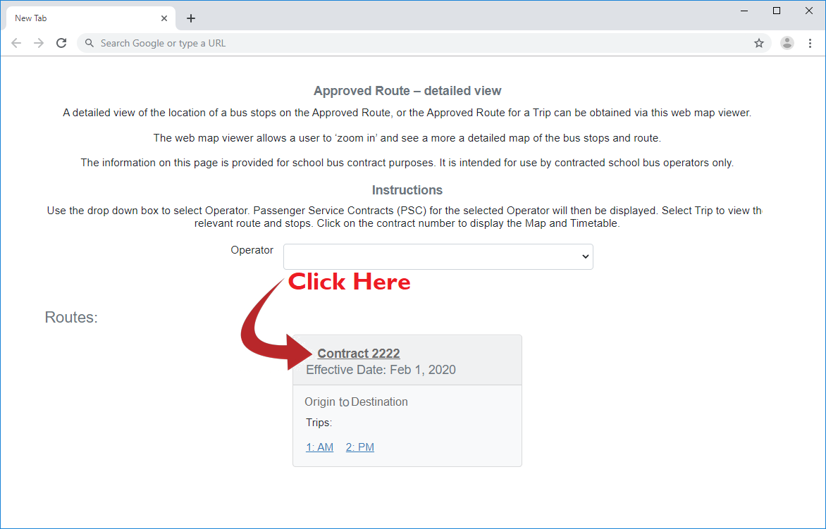
The PSC Details Website address is https://www.transport.tas.gov.au/psc-details

General Access network changes launched 3 October 2021
Northern, North West and Intercity timetable and route improvements were launched on Sunday 3 October 2021. These changes are a result of the Passenger Transport Branch listening to operator and public feedback following the launch of the new North-West network in January this year.
The Passenger Transport Branch is pleased to have worked closely with Manion’s Coaches, Merseylink, and Redline to make these revisions. The changes include:
- Timetable adjustments for better accuracy in urban Devonport, the North West Express and on the Intercity service.
- Reduced wait times for transfers between the North West Express and Intercity services in Devonport.
- Changing some regional towns to a booking basis, making the Intercity services faster.
- New bus stops on the North West Express to better connect the South Burnie precinct.
- Replacing a stop on the Bass Highway (near the Latrobe roundabout) with a safe and accessible, Disability Discrimination Act (DDA) compliant, stop at the Mersey Community Hospital.
These changes have been communicated to passengers and transport stakeholders in the region through posters, flyers, letters, and information on the Transport Tasmania website.

Student free travel bus passes 2022
Students who hold a Bus Pass for Free Travel with an expiry in 2021 and who are still eligible for free travel will need to reapply for a pass from 2022 onwards.
Students whose pass expires in 2021 will receive either an email or letter from State Growth in November, reminding them to reapply early if still eligible, to beat the rush. Due to the high volume of applications received each year, applications submitted in January may take longer to process.
Students with free travel eligibility applied to a Metro or Tassielink Greencard should retain their card. If they are applying again and are eligible for free travel in 2022, their existing card will be updated.

Student fare increase 2022
Since 2017 the Tasmanian Government’s policy has been to increase the student fare by ten cents every second year, where an increase is supported by the Consumer Price Index (CPI).
There has not been a student fare increase since 2019 because the fare increase scheduled for 2021 was deferred due to the impacts of COVID-19 on the economy.
This state-wide student fare increase is now to take effect in January 2022. The student cash fare will increase from $1.80 to $1.90, and the multi-trip or smartcard discounted fare will increase from $1.44 to $1.52.
The Passenger Transport Branch will be working with you to plan for this and support you to share information with your passengers. More information will be shared with you soon regarding the timing of the fare increase, and consideration of the impacts on ticket sales, patronage reporting and public communications.

Contacting Passenger Transport
- Operator enquiries: ptscontracts@stategrowth.tas.gov.au
- Public enquiries: ptfeedback@stategrowth.tas.gov.au
- Phone: 03 6166 3343

