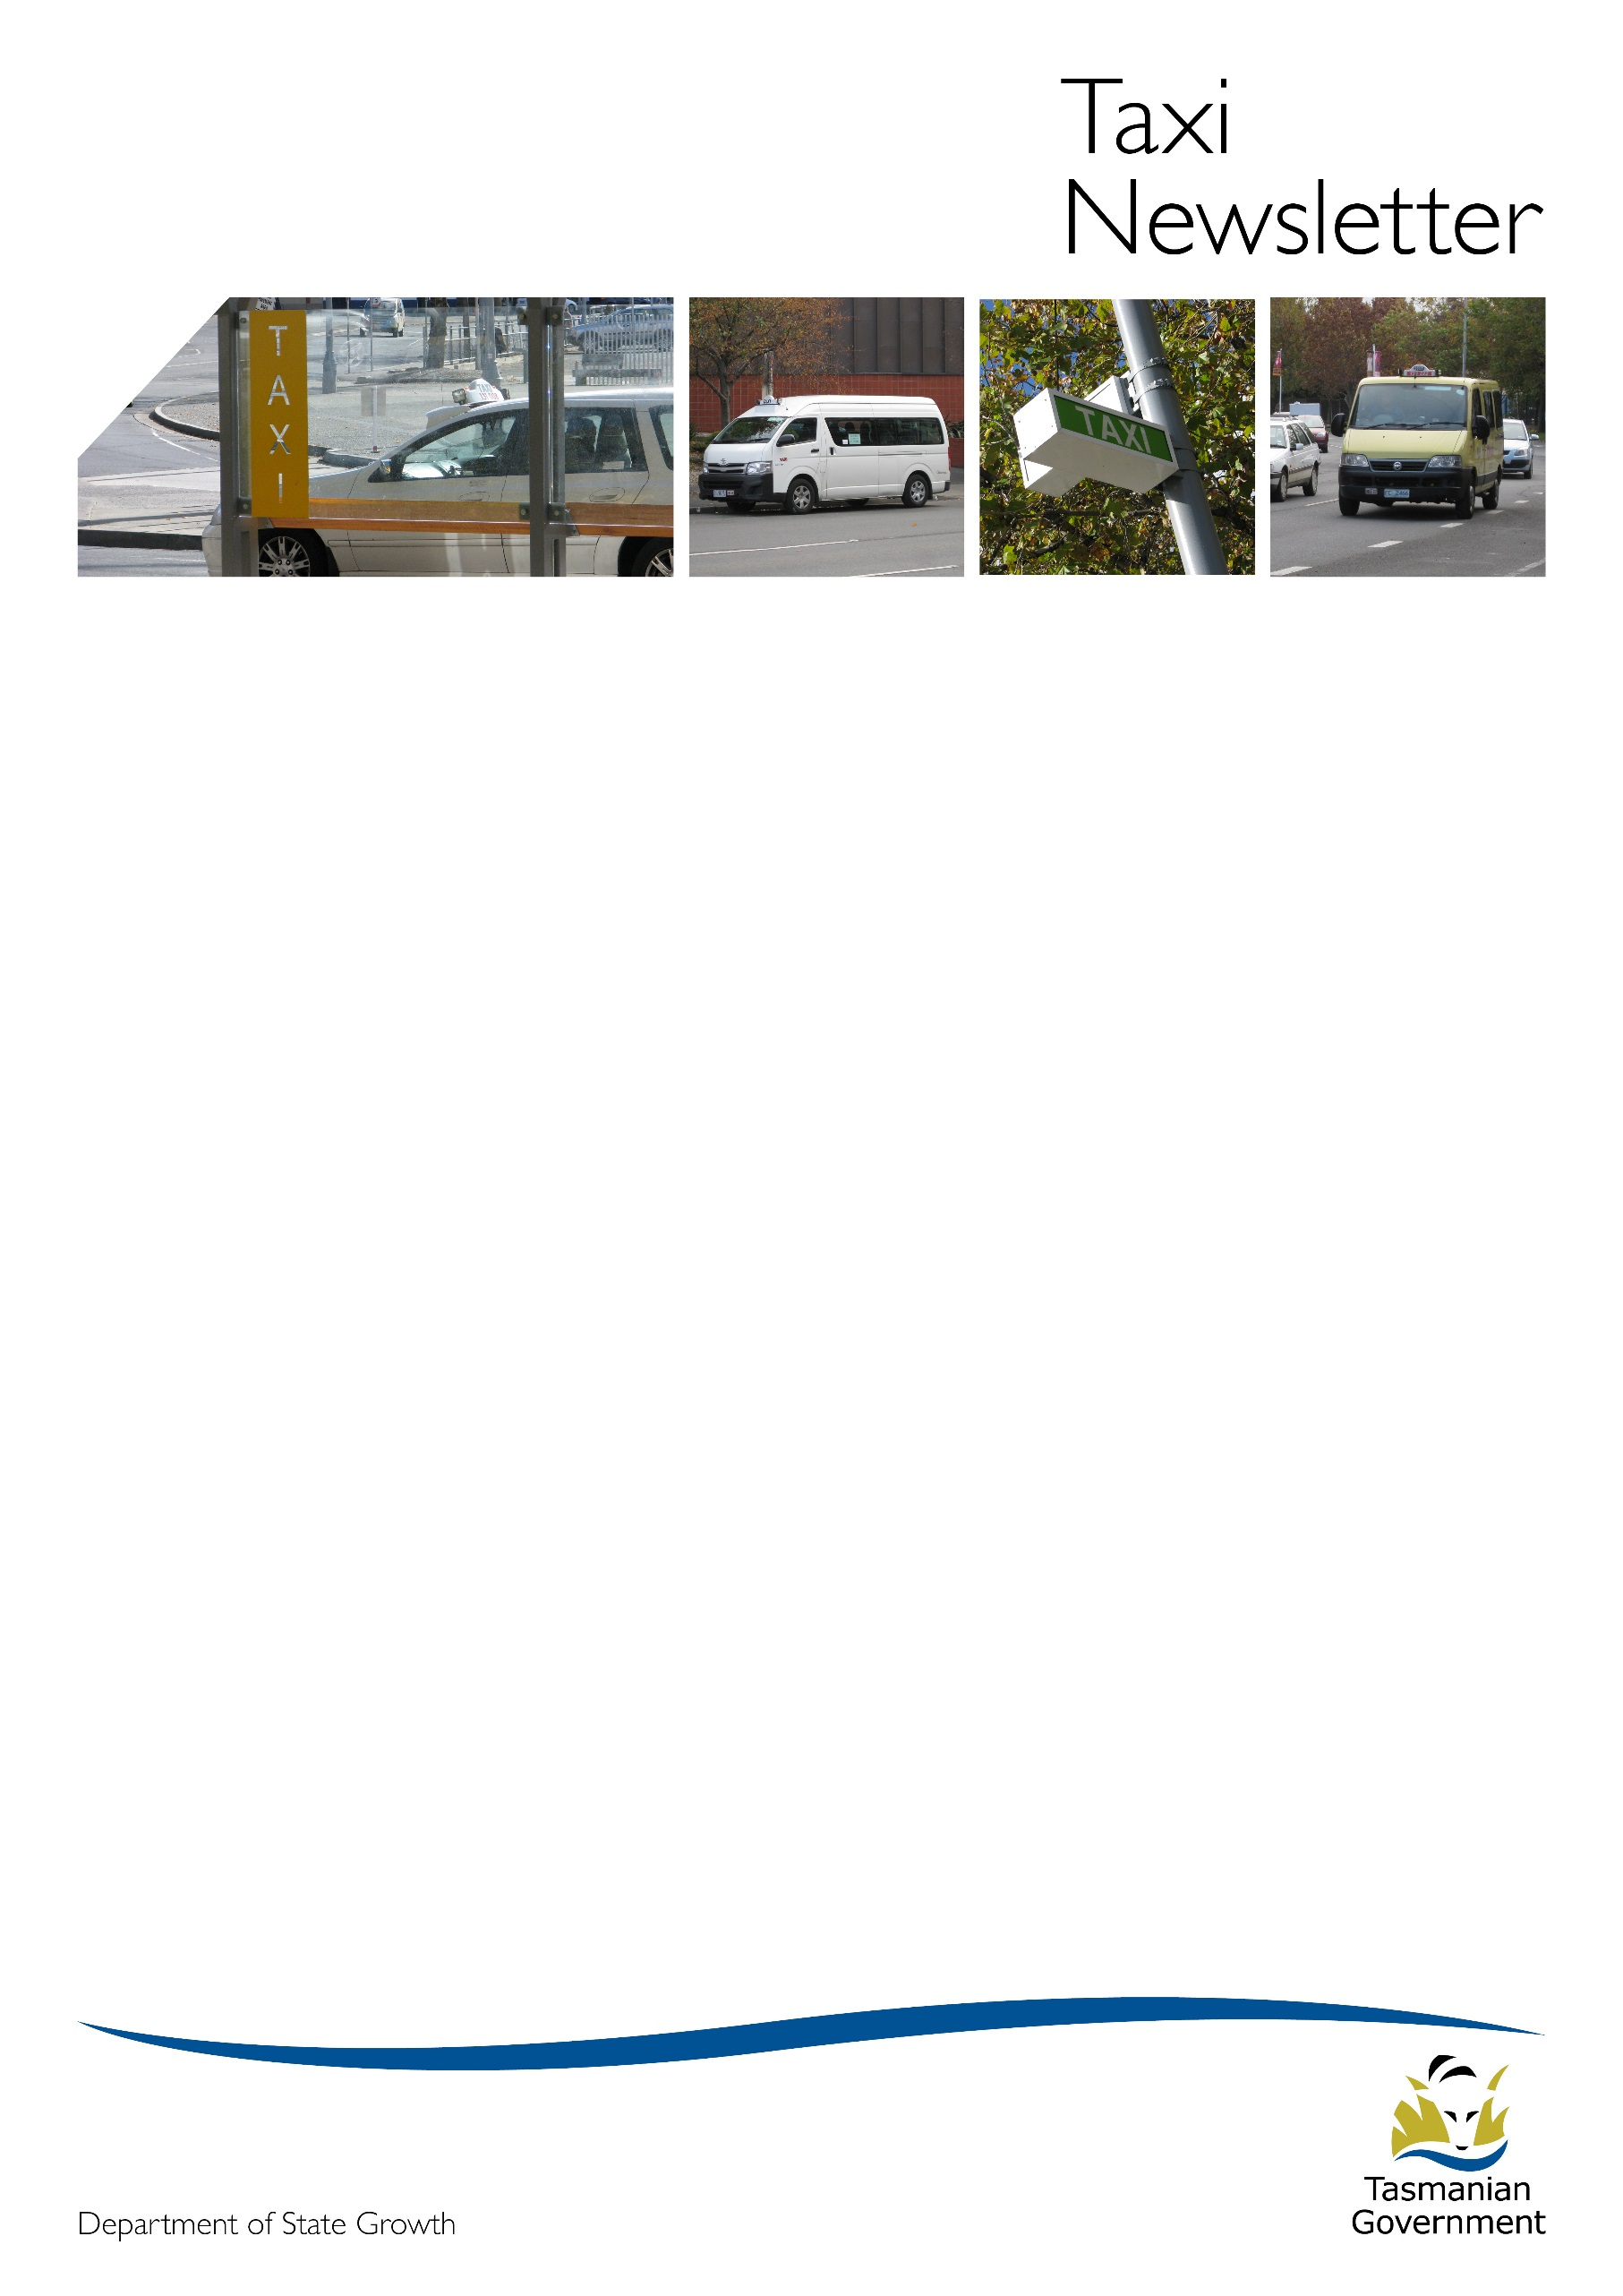
Welcome to the August 2018 edition of the Taxi Newsletter.
New approved taxi security camera system
The 13CABSi (model number 1) is a new security camera system supplied by TaxiTech Pty Ltd which has been approved for use in Tasmania by the Transport Commission on 4 July 2018.

The list of authorised taxi security camera systems agents has been updated to show the approved installer, testers and downloaders of the new system on the Department of State Growth’s (State Growth) website at: https://www.transport.tas.gov.au/passenger/operators/authorised_taxi_security_camera_systems_agents.
Small Passenger Vehicle Review
As part of its First Year Agenda, the Government has committed to release a draft regulatory framework for on-demand passenger transport for public consultation prior to 30 September 2018. Preparations are underway to deliver on this commitment and further advice regarding the details of the consultation will be provided in due course.
The review of the taxi and hire vehicle industries has so far comprised a review of background and context including the existing regulatory framework, an initial round of consultation, market research, targeted consultation, observation of the development of new regulatory frameworks in other Australian states and territories, and ad hoc stakeholder engagement. The in-depth and robust review has provided a sound base for the development of an on-demand passenger transport framework that is modern, safe, competitive, accessible and appropriately regulated.
If there are any matters you would like to raise with the taxi and hire vehicle industries review team, please email taxireview@stategrowth.tas.gov.au.
Release of owner-operator taxi licences for 2018
The release of Owner-Operator Taxi Licences (OOTLs) was suspended for every Tasmanian taxi area in response to the entry of ride-sourcing services in the Hobart area for 2016, 2017 and 2018. Earlier this year, the Minister determined the suspension would be lifted due to reported demand for additional taxi services in taxi areas where ride-sourcing services had not entered the market.
Before the end of September 2018, a total of 27 OOTLs will be made available for Tasmanian taxi areas with the exception of the Hobart taxi area. These will be available by way of tender. The tender will be advertised in the major Tasmanian newspapers as well as on the State Government’s procurement website.
Passengers at taxi ranks
Passengers may catch a taxi from a taxi rank or by hailing a passing taxi or by phoning a taxi company.
A passenger can take any taxi they choose from a taxi rank. They can choose to take a taxi other than the first taxi at the rank. A taxi driver who tells a passenger to take the first taxi is refusing a fare. The driver is committing an offence under regulation 15 of the Taxi Industry Regulations 2008 (the Regulations) and a fine may apply. The Regulations are available online at: https://www.legislation.tas.gov.au/view/html/inforce/current/sr-2008-111.
A driver who witnesses unacceptable behaviour at a taxi rank should report it to Tasmania Police. Complaints about fare refusal should be reported to the Regulations and Concessions Unit.
Transport Access Scheme (TAS) – Taxi Subsidy Program fraud
The Taxi Subsidy Program is administered by State Growth and is intended to provide assistance to members of the Tasmanian community who live with a disability that affects their mobility.
By most accounts the program works well, in no small part thanks to the drivers and operators who deliver the service. The relationship is mutually beneficial as the Department subsidised more than $5.9 million in taxi travel for members last financial year alone. This money goes directly into the industry and promotes taxi travel as an option for members who might not otherwise be able to afford to use a taxi.
Disappointingly, a small number of drivers have been found to have been defrauding the program. Recently, a driver in Hobart was referred to Tasmania Police.
State Growth is committed to investigating fraudulent claiming against the Taxi Subsidy Program. Every subsidy claim results in a record which is held by the Department, and these records are routinely audited by compliance officers for fraud detection. Where an internal investigation determines that evidence of fraudulent claiming exists, the matter is referred to Tasmania Police.
Fraudulent claiming is detrimental to the Taxi Subsidy Program, and also hurts the taxi industry by keeping dishonest drivers and operators in business and taking fares away from those who support the program. If you become aware of fraudulent claiming within the industry, you can report it to the Department on (03) 6166 3338 or emailing ptsbs@stategrowth.tas.gov.au.
Requirement to hold, own or lease a licence
You cannot operate a taxi service unless you hold, own or lease a taxi licence.
- A perpetual taxi licence (PTL) may be leased.
- Owner-operator taxi licence (OOTL) and wheelchair-accessible taxi (WAT) licences cannot be leased and it is illegal to enter into any agreement purporting to lease an OOTL or WAT licence.
If you own or lease a PTL then you need to know your responsibilities to notify the Commission about a lease in accordance with the Regulations:
- The owner of a PTL must notify the Commission within 14 days that a lease has commenced.
- The owner and the lessee of a PTL must notify the Commission within 7 days that a lease has terminated.
A form for notifying the commencement or termination of lease is available on State Growth’s website at: https://www.transport.tas.gov.au/fees_forms/operator_forms.
There is a $15.80 fee to notify the commencement of a lease. The fee can be paid at any Service Tasmania shop. When the fee is paid, the Commission will send the owner of the PTL a new licence document. There is no fee to notify the termination of a lease.
An operator can only use an OOTL or WAT licence if they own it. OOTLs and WATs may be transferred to a new holder on the approval of the Commission. Application forms are available on State Growth’s website.
The Transport Commission may cancel an OOTL or WAT licence if it is satisfied that the holder has entered into an agreement to lease the licence.
State Growth’s Transport Safety and Investigation Unit
State Growth transferred responsibility for heavy vehicle compliance and enforcement to the National Heavy Vehicle Regulator (NHVR) on 2 July 2018. This has had very little impact for the taxi industry. The compliance and enforcement services that remain with State Growth continue to be delivered regionally with the team based in Launceston, Burnie and Hobart. The team is now known as the Transport Safety and Investigation Unit (the Unit).
Transport Safety and Investigation Officers have the same uniform but you will soon see some significant changes in their vehicles’ appearance to make them more visible on the road.
Public Passenger Vehicle on-road compliance and enforcement
The Unit provides on-road compliance and enforcement activities for the Public Passenger Vehicle (PPV) sector. This includes:
- buses (heavy and light);
- taxis;
- restricted hire vehicles;
- luxury hire vehicles; and
- ride-sourcing services (such as Uber and Shebah).
The focus of the Unit’s on-road compliance and enforcement activities include:
- ancillary certificate checks;
- driver licence checks;
- scheduled vehicle compliance inspections;
- taxi operation checks (including compliance with areas and fares);
- taxi vehicles and equipment checks (including tariff lights, camera and meters); and
- accreditation checks.

For more information, please contact
State Growth’s Transport Safety and Investigation Unit:
- Phone: (03) 6777 1936
- Email: transport.safety@stategrowth.tas.gov.au
- Post: PO Box 1906, Launceston TAS 7250

Regulations and Concessions Unit
For operator accreditation or taxi licence enquiries:
Email: operator.accreditation@stategrowth.tas.gov.au

